Case Study Report



**Tech Saksham**

Data Analytics with Power BI

**“****An Analysis of Unemployment in Republic of India”**

**“Shrimati Indira Gandhi college”**

|  |  |
| --- | --- |
| **NM ID** | **NAME** |
| CBD4EC137912D7ABC9A47DE3A1CF3E27 | PRATHINA V |

|  |  |
| --- | --- |
|  |  |
|  | Trainer Name Mrs.Umamaheshwari |
|  | Master Trainer Mrs.Umamaheshwari |

**ABSTRACT**

In the context of the Republic of India, this project titled "An Analysis of Unemployment in Republic of India (Data Analytics with Power BI)" aims to utilize Power BI, a prominent business intelligence tool, to examine and visualize unemployment data. Unemployment, a state where individuals actively seek employment but remain unsuccessful, is a critical measure of economic strength. The unemployment rate, calculated by dividing the number of jobless individuals by the total population in the labor force, is a widely used indicator of a country's employment situation. By analyzing real-time data, this project seeks to provide insights into the patterns, trends, and demographics of unemployment in India. Governments, both national and local, often strive to provide job opportunities for eligible individuals, offering work at a minimum wage and creating avenues for permanent employment to reduce overall unemployment rates.

Despite efforts to reduce unemployment, the rate in India has been steadily increasing. This project aims to analyze the factors contributing to unemployment and its impact on the Indian economy. The study focuses on the role of the employment rate in the overall economic development. The objective is to enable policymakers, researchers, and stakeholders to make informed decisions, formulate effective policies, and implement targeted interventions to address unemployment challenges. This project aligns with the broader agenda of promoting data-driven decision-making and fostering socio-economic development in India.

**INDEX**

|  |  |  |
| --- | --- | --- |
| **Sr. No.** | **Table of Contents** | **Page No.** |
| 1 | Chapter 1: Introduction | 1 |
| 2 | Chapter 2: Services and Tools Required | 4 |
| 3 | Chapter 3: Project Architecture | 7 |
| 4 | Chapter 4: Modeling and Result | 9 |
| 5 | Conclusion | 18 |
| 6 | Future Scope | 19 |
| 7 | References | 20 |
| 8 | Links | 21 |

**CHAPTER 1**

**INTRODUCTION**

* 1. **Problem Statement**

The word unemployment belongs to a state in which a respective actively seeks employment but is unsuccessful. It is said to be one of the critical measures of the economy's strength. The unemployment rate is the most generally used method to arbitrate a country's unemployment rate. This can be found by honestly dividing the number of people without jobs by the total population covered in a nation's labour force. National and local governments often effort to offer employment convenience to secure people who meet the acceptability criteria set by them. Commonly, work is availed for groups of particular upon a fixed minimum wage sufficient for bare continuance and provides further chances for them to find permanent jobs. These attempts are made to develop the country's growths and cut down the overall unemployment rate. The rate of unemployment in India has been expanding over the years. The current paper purpose to interpret the element leading to unemployment and its impact on the Indian economy. The study focal point on how employment rate performance a vital role in overall advancement of the economy.

* 1. **Proposed Solution**

Develop a PowerBI analytics platform to analyze real-time employment data in India. Integrate data from various sources including government reports and surveys. Utilize visualizations to identify trends and patterns in unemployment rates, regional disparities, and skill gaps. Provide real-time monitoring and policy recommendations to address root causes of unemployment and promote economic growth. Engage stakeholders for collaborative efforts in tackling unemployment challenges.

* 1. **Feature**
* **Real-Time Monitoring:** The platform will offer real-time monitoring of unemployment data, allowing for immediate insights into changes and trends.
* **Demographic Segmentation:** It will segment the unemployed population based on factors such as age, education level, geographical location, and industry.
* **Trend Identification:** The platform will identify and visualize trends in unemployment rates, regional disparities, and industry-specific job losses or gains.
* **Predictive Modeling:** Using historical data, the platform will employ predictive analytics to forecast future unemployment trends and potential impacts on the economy.
  1. **Advantages**
* **Real-Time Monitoring:** The platform will offer real-time monitoring of unemployment data, allowing for immediate insights into changes and trends.
* **Demographic Segmentation:** It will segment the unemployed population based on factors such as age, education level, geographical location, and industry.
* **Trend Identification:** The platform will identify and visualize trends in unemployment rates, regional disparities, and industry-specific job losses or gains.
* **Predictive Modeling:** Using historical data, the platform will employ predictive analytics to forecast future unemployment trends and potential impacts on the economy.
  1. **Scope**

The scope of this project encompasses all entities involved in addressing unemployment challenges, including government agencies, non-profit organizations, and research institutions. It can be expanded to incorporate additional data sources and advanced analytics techniques, such as machine learning and artificial intelligence, to provide deeper insights into unemployment trends and potential interventions. Additionally, the project's methodologies and insights can be adapted for use in other sectors, such as education, workforce development, and social services, where understanding employment dynamics is essential. Furthermore, this initiative contributes to the broader goal of socioeconomic development by promoting evidence-based policymaking, fostering collaboration across sectors, and empowering communities to address unemployment effectively.

**CHAPTER 2**

**SERVICES AND TOOLS REQUIRED**

**2.1 Services Used**

* **Data Collection and Storage Services**: Banks need to collect and store customer data in real-time. This could be achieved through services like Azure Data Factory, Azure Event Hubs, or AWS Kinesis for real-time data collection, and Azure SQL Database or AWS RDS for data storage.
* **Data Processing Services**: Services like Azure Stream Analytics or AWS Kinesis Data Analytics can be used to process the real-time data.
* **Machine Learning Services**: Azure Machine Learning or AWS SageMaker can be used to build predictive models based on historical data.

**2.2 Tools and Software used**

**Tools**:

* **PowerBI**: The main tool for this project is PowerBI, which will be used to create interactive dashboards for real-time data visualization.
* **Power Query**: This is a data connection technology that enables you to discover, connect, combine, and refine data across a wide variety of sources.

**Software Requirements**:

* **PowerBI Desktop**: This is a Windows application that you can use to create reports and publish them to PowerBI.
* **PowerBI Service**: This is an online SaaS (Software as a Service) service that you use to publish reports, create new dashboards, and share insights.
* **PowerBI Mobile**: This is a mobile application that you can use to access your reports and dashboards on the go.

**CHAPTER 3**

**PROJECT ARCHITECTURE**

**3.1 Architecture**

**USER FRONTEND BACKEND**

|  |  |  |
| --- | --- | --- |
|  | **HTML 5** | **NODEJS 14.0**  **Database** |

Here’s a high-level architecture for the project:

1. **Data Collection**: Real-time customer data is collected from various sources like bank transactions, customer interactions, etc. This could be achieved using services like Azure Event Hubs or AWS Kinesis.
2. **Data Storage**: The collected data is stored in a database for processing. Azure SQL Database or AWS RDS can be used for this purpose.
3. **Data Processing**: The stored data is processed in real-time using services like Azure Stream Analytics or AWS Kinesis Data Analytics.
4. **Machine Learning**: Predictive models are built based on processed data using Azure Machine Learning or AWS SageMaker. These models can help in predicting customer behavior, detecting fraud, etc.
5. **Data Visualization**: The processed data and the results from the predictive models are visualized in real-time using PowerBI. PowerBI allows you to create interactive dashboards that can provide valuable insights into the data.
6. **Data Access**: The dashboards created in PowerBI can be accessed through PowerBI Desktop, PowerBI Service (online), and PowerBI Mobile.

**CHAPTER 4**

**MODELING AND RESULT**

**Analyzing Unemployment: Key Data Insights**

The unemployment dataset, presented in a single Excel sheet, comprises four primary columns: age, year, gender, and the sum of unemployed years. The "age" column denotes the age of individuals included in the dataset, providing insights into how unemployment rates vary across different age groups. The "year" column indicates the specific year for which the unemployment data is recorded, allowing for temporal analysis of unemployment trends over time. The "gender" column categorizes individuals based on their gender, facilitating analysis of gender disparities in unemployment rates. Lastly, the "sum of unemployed years" column aggregates the total duration of unemployment experienced by individuals within the dataset, offering insights into the cumulative impact of unemployment. While the dataset lacks inter-file relationships, these columns enable various analytical approaches to understand and address unemployment challenges effectively.

**Model View:**

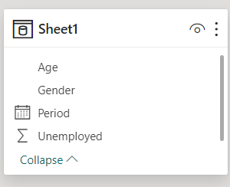

**Report of unemployment based on year, gender and month:**

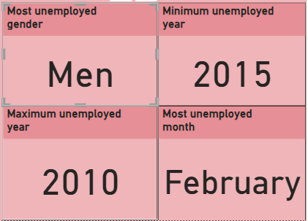

Card view

* **Most unemployed Gender:** Men
* **Minimum unemployed year:** 2015
* **Maximum unemployed year:** 2010
* **Most unemployed Month:**  February

**Total unemployment by age and gender:**

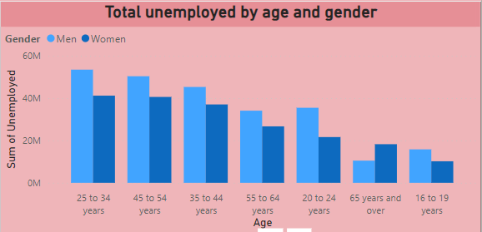

Clustered column chart view

**Total unemployment by age group:**

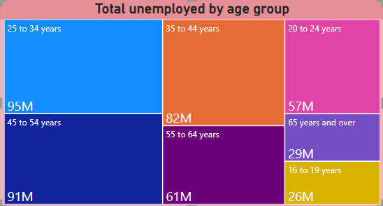

Tree map view

**Total unemployed by year and gender:**

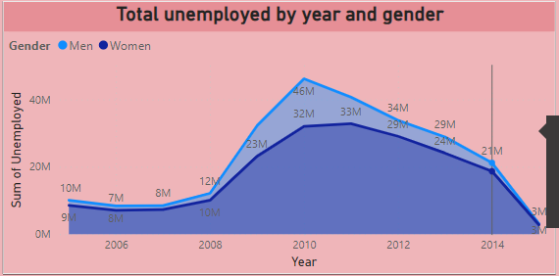

Stacked area chart view

**Dashboard:**

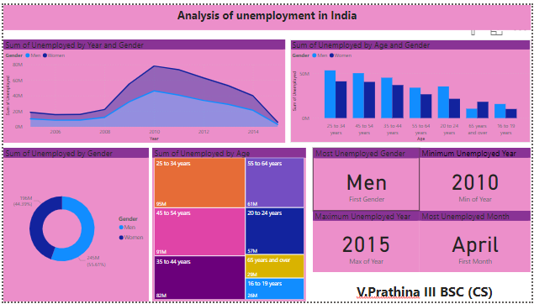

**CONCLUSION**

The project “An analysis on unemployment in India” using PowerBI has successfully demonstrated the potential of data analytics inIndia. The culmination of the analysis on unemployment in India underscores the pivotal role of data analytics, particularly through Power BI, in comprehensively understanding and addressing economic challenges. Through real-time examination of unemployment data, valuable insights into demographic trends, disparities, and their implications on economic growth have been elucidated. The utilization of interactive dashboards and reports has not only enhanced decision-making capabilities but also emphasized the significance of data visualization in simplifying complex information. This endeavor underscores the imperative for evidence-based policymaking and collaborative efforts across sectors to mitigate unemployment's adverse effects and foster sustainable socio-economic development in India.

**FUTURE SCOPE**

The prospective horizons for this project are expansive. With advancements in analytics and machine learning, Power BI holds the promise of forecasting future unemployment trends based on historical data. Incorporating predictive analytics could empower policymakers to anticipate labor market fluctuations and implement preemptive strategies to mitigate unemployment risks. Moreover, Power BI's versatility in data integration allows for the inclusion of diverse datasets, offering a more comprehensive understanding of the unemployment landscape.

In light of escalating concerns surrounding data privacy and security, forthcoming iterations of this project must prioritize robust data governance frameworks. By ensuring stringent measures for handling sensitive employment data, compliance with data protection regulations can be upheld, fostering trust and safeguarding individuals' privacy.

Furthermore, exploring the integration of real-time data streams presents an opportunity to enhance the timeliness and relevance of insights. This could revolutionize how policymakers and stakeholders engage with employment dynamics, potentially leading to more agile interventions and, ultimately, improved socio-economic outcomes.

**REFERENCES**

https://www.youtube.com/live/yQ8bT9AI4yc?si=vjuEB_52G4S2FYbq

**LINK**

[Prathina1004/project (github.com)](https://github.com/Prathina1004/project)